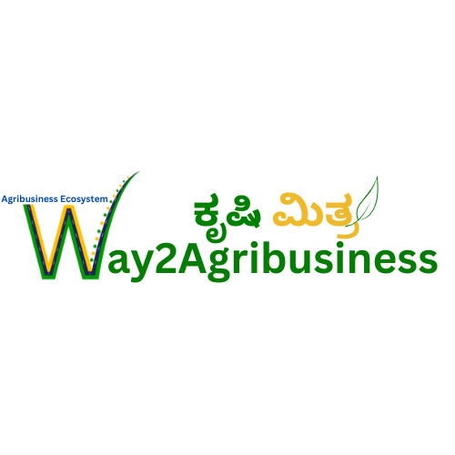

Internship Task
Django, Fast API and AI-ML

Introduction
You are required to come up with a solution for the provided business case in the next section.
Submission Requirements

- Submit your solution in Jupyter Notebook (.ipynb) format.
- Send a copy via WhatsApp to +91 9449004956.
- Email a copy to way2agriintelai@gmail.com, and include your name and contact number in the message.
- Your Updated Resume

Note: Failure to include contact details (phone number and email ID) will lead to rejection of the submission.
Business Context
This case requires trainees to develop a model to forecast average monthly prices for the next 12 months using the provided dataset. The data is available in CSV format and contains historical monthly prices. Candidates may use “any” suitable machine learning, deep learning, statistical time series forecasting method or any other appropriate technique of their choice.

Following standard model development procedures, the model should be trained on historical data and evaluated for both training and predictive performance on future months. It is recommended to dedicate sufficient time to fine-tuning the model and interpreting the results.

Data Dictionary & Source Acquisition
- Data Dictionary: The data dictionary of the dataset can be found here
- Data Source: The dataset can be found here

Candidate Expectations
Your task is to execute the process for predicting monthly prices while answering the following questions:
- Perform data cleaning, including handling missing values, outliers, and anomalies.
- Describe your price prediction model in detail and explain the reasons for selecting this model.
- Demonstrate the performance of the model using appropriate evaluation metrics.
- Suggest actions a company could take to respond to predicted price changes.
- Assuming these actions have been implemented, how would you determine if they are effective?
- Explain how you would deploy the model to production using Django.
- Describe how you would integrate the model into a Django- and FastAPI-based web application for real-time predictions.
- Describe how you would integrate the APIs generated using Django and FastAPI into frontend frameworks such as Next.js and React Native.
- Explain how you would monitor the model in production, including tracking performance, handling model drift, and updating the model as needed.

